Sales Trend and Customer Behavior Analysis – McDonald’s
(Exploratory Data Analysis Report)

Objectives of the Study
The objective of this project is to analyze McDonald's sales data to understand revenue trends, customer purchasing behavior, and product performance. The study focuses on identifying top-performing categories, peak sales periods, and time-based patterns to generate meaningful business insights. An interactive dashboard is created to visually represent key metrics and support data-driven decision-making.
1️ Executive Summary
This report presents an Exploratory Data Analysis (EDA) of McDonald’s sales dataset to understand revenue trends, customer purchasing behavior, product performance, and time-based sales variations. Using Excel and Power Query, the dataset was cleaned, transformed, and analyzed to generate meaningful business insights.
An interactive dashboard was developed to visualize key performance indicators such as total revenue, total orders, average items per order, category-wise sales, and weekday vs weekend performance.
The findings highlight that evening hours and core product categories significantly drive revenue, while weekends present opportunities for improvement through targeted strategies.
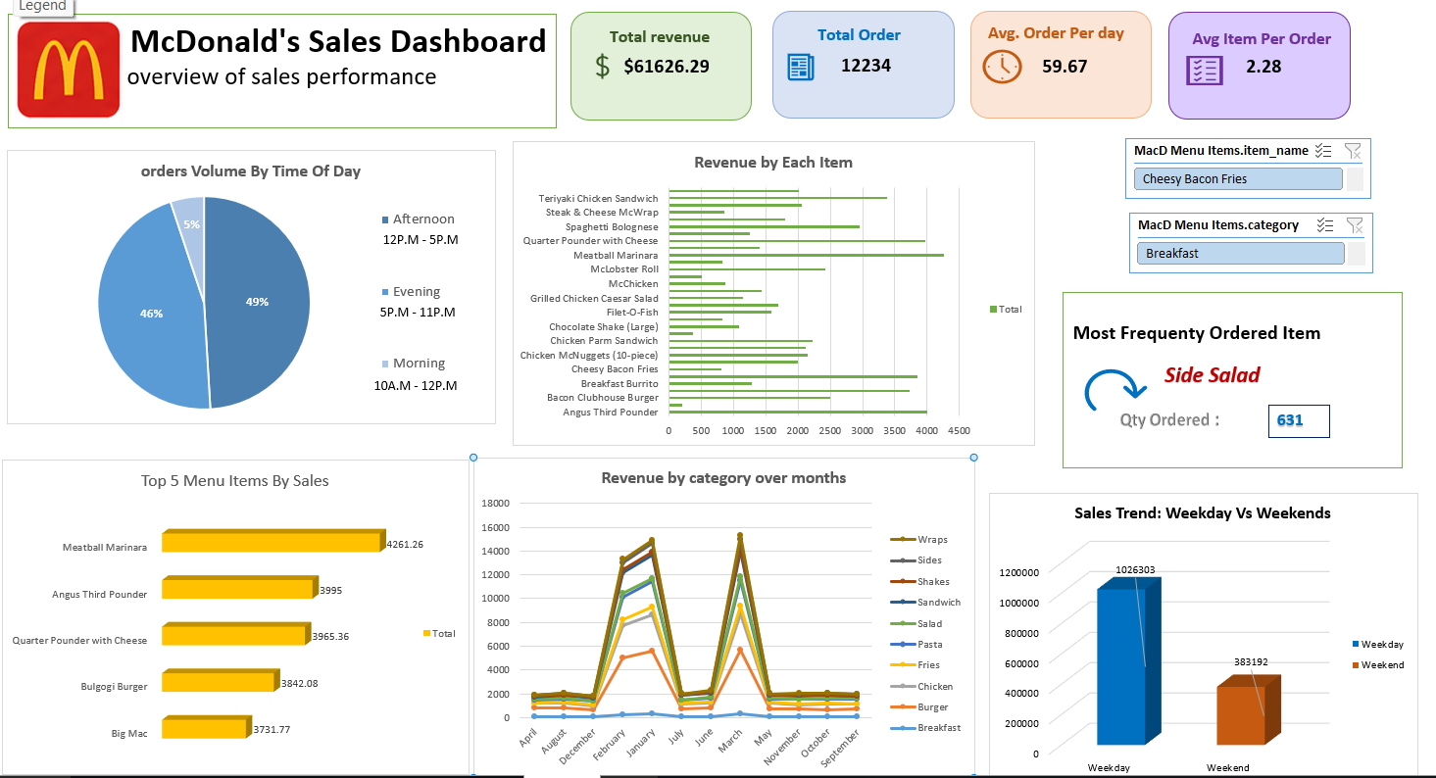

2️ Introduction
In today’s competitive food and beverage industry, data-driven decision-making plays a crucial role in improving operational efficiency and maximizing profitability. This project focuses on conducting an Exploratory Data Analysis (EDA) of McDonald’s sales dataset to identify patterns in sales performance, item popularity, and customer purchasing behavior.
The primary objective of this analysis is to:
- Analyze revenue trends across categories and months
- Identify peak sales hours
- Compare weekday and weekend performance
- Determine most frequently ordered items
- Provide actionable business recommendations
The final outcome of this study is an interactive Excel dashboard that enables stakeholders to explore data dynamically using slicers and filters.

3️ Dataset Overview
1.1 Data Source Description
The dataset consists of two primary tables:
🔹 Table 1: MacD Menu Items
This table contains product-level information related to menu items. It has 4 columns and 32 rows.
Key Columns:
- Menu_Item id
- Item Name
- Category (Burgers, Beverages, Chicken, Desserts, Snacks, etc.)
- Price
This table provides static product information and helps in analyzing:
- Category-wise pricing
- Product distribution
- Revenue contribution by category
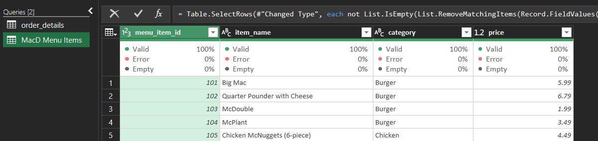

🔹 Table 2: Order Details
This table contains transaction-level data. It has 9 columns and 12234 rows.
Key Columns:
- Order ID
- Order Details ID
- Order Date
- Order Time
- Item ID
- Month Name
- Time Slots (Morning, Afternoon, Evening, Night)
- Sales (Assumed Sales Value since Qty = 1)
- Weekday/Weekend
This table captures:
- Sales timing patterns
- Customer ordering behavior
- Daily & hourly trends
- Weekday vs Weekend comparison
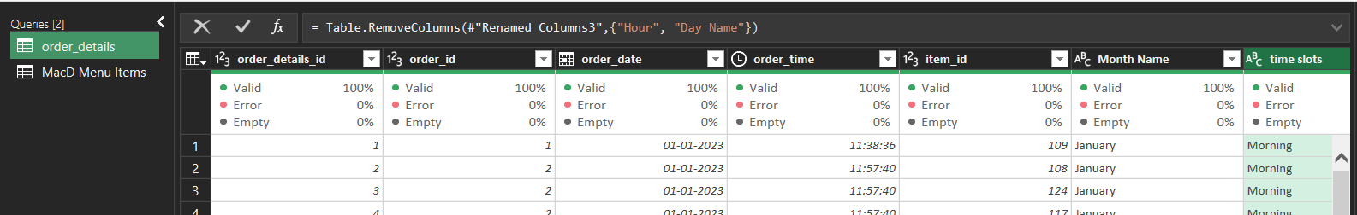

4️ Data Cleaning and Preparation
Before analysis, the dataset was cleaned and transformed to ensure accuracy and reliability.
4.1 Duplicate Removal
Duplicate records were identified and removed using Power Query’s “Remove Duplicates” feature to prevent double counting of revenue.

4.2 Handling Missing Values
- Checked for null values in critical columns.
- Applied backward fill in the table order details for item ID column

4.3 Data Type Correction
Columns were converted to appropriate formats:
- Date → Date format
- Time → Time format
- Order ID→ Number format
- Price & Sales → Currency

4.4 Feature Engineering (Derived Columns)
New columns created:
- Sales
- Month Name
- Hour
- Time Slot (Morning/Afternoon/Evening)
- Weekday/Weekend

5️ Univariate Analysis
Univariate analysis examines individual variables independently.
Key Observations:
- Order IDs repeat, indicating multi-item purchases.
- Prices vary significantly across categories.
- Evening hours show higher frequency of orders.
- Categories are unevenly distributed in terms of item count.

6️ Bivariate Analysis
This section explores relationships between two variables.
6.1 Sales vs Time Slot
Evening and afternoon generate higher revenue compared to morning.
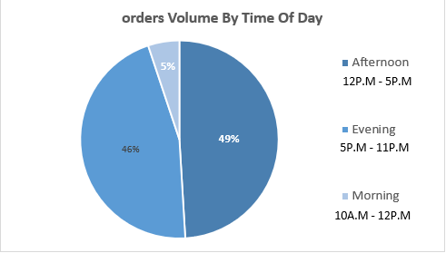

6.2 Sales vs Items
Revenue fluctuates across items, indicating taste variations.
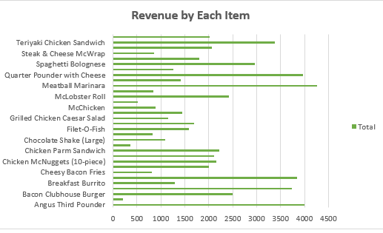

6.3 Sales vs Weekday/Weekend
Weekday sales exceed weekend sales.
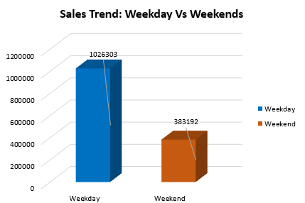

7️ Multivariate Analysis
Examines interactions between three or more variables.
7.1 Month + Category + Sales
Certain categories perform better in specific months.
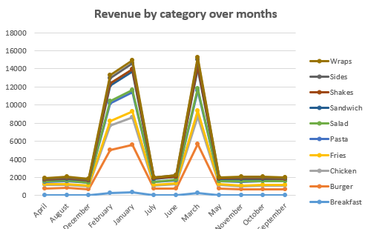

8️ Dashboard Overview
An interactive dashboard was created to summarize key metrics:
- Total Revenue
- Total Orders
- Average Order per Day
- Average Items per Order
- Top 5 Items
- Category-wise Revenue
- Time-based Order Distribution
The dashboard includes slicers for item and category filtering.
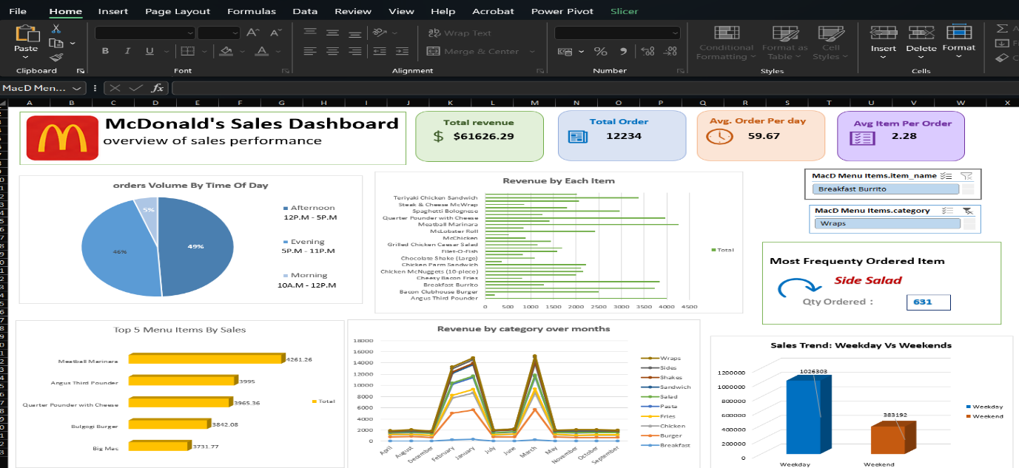

9️ Trend Analysis
- The sales trend analysis highlights clear patterns in revenue generation, order distribution, and customer purchasing behavior across different time dimensions. Monthly revenue trends indicate fluctuations in category-wise performance, with certain months recording noticeable peaks. Core product categories such as Burgers, Wraps, and Sandwiches consistently contribute the highest share of revenue, demonstrating stable and recurring consumer demand.
- Time-based analysis reveals that the Evening (5 PM – 11 PM) and Afternoon (12 PM – 5 PM) time slots account for the majority of total orders. This indicates that customer traffic is strongest during lunch and dinner hours, reflecting typical urban dining patterns.
- The comparison between weekdays and weekends shows that weekday sales significantly exceed weekend sales. This suggests that routine visits by working professionals and students drive consistent weekday revenue.
- Furthermore, the Top 5 menu items contribute a substantial portion of overall sales, indicating revenue concentration among a limited set of high-performing products.
- Overall, the sales trend is influenced by:
- Time-of-day purchasing patterns
- Day-type variations (weekday vs weekend)
- Category popularity
- Monthly fluctuations and seasonality

Key Insights
The analysis of the dataset generated the following important insights:
  - High Revenue Concentration in Core Categories
Burgers, Wraps, and Sandwiches dominate total revenue contribution, indicating strong customer preference for core fast-food offerings.
  - Evening Is the Peak Revenue Window
A significant percentage of total daily sales occurs during evening hours, making it the most critical operational period.
  - Weekdays Drive Higher Revenue
Sales performance during weekdays surpasses weekends, highlighting consistent daily customer engagement.
  - Top 5 Items Generate Major Sales Share
A small number of menu items account for a large portion of total revenue, suggesting product concentration.
  - Moderate Average Items per Order
The average number of items per order indicates limited cross-selling, presenting opportunities for increasing basket size.
  - Most Frequently Ordered Item Reflects Strong Brand Preference
One menu item stands out in order frequency, showing high popularity and customer loyalty.

Recommendations
Based on the insights derived from the analysis, the following strategic recommendations are proposed:
- ✔ Optimize Peak-Hour Operations
Increase workforce allocation and ensure faster service during evening peak hours to maximize revenue potential.
- ✔ Enhance Weekend Sales Strategies
Implement targeted weekend promotions, combo offers, or loyalty discounts to stimulate higher weekend traffic.
- ✔ Leverage High-Performing Categories
Focus marketing campaigns on Burgers and Wraps while introducing innovative variants to maintain demand.
- ✔ Improve Cross-Selling Techniques
Train staff to suggest add-ons such as beverages, fries, or desserts to increase average order value.
- ✔ Introduce Seasonal Marketing Campaigns
Use monthly trend insights to design promotional strategies during high-performing months.
- ✔ Inventory Planning Based on Demand Trends
Maintain adequate stock levels for top-performing items to avoid stock-outs during peak hours.
- ✔ Product Diversification Strategy
Promote low-performing items through bundling strategies to balance category contribution.

Conclusion
The exploratory data analysis of the McDonald's sales dataset provides comprehensive insights into revenue drivers, customer purchasing behavior, and operational performance. The findings demonstrate that sales are heavily influenced by time-of-day trends, weekday dominance, and product category popularity.
Core categories such as Burgers and Wraps consistently contribute the highest revenue, while evening hours represent the most profitable time segment. Although weekday performance is strong, weekends present growth opportunities through targeted marketing strategies.
The interactive dashboard successfully transforms raw transactional data into meaningful business intelligence. By leveraging these insights, management can make data-driven decisions to improve operational efficiency, enhance customer satisfaction, and increase overall profitability.
This study reinforces the importance of data analytics in modern business environments and highlights how structured EDA can uncover actionable insights for strategic planning.

